40 Hour Virtual RSO Certification Course
November , 2021

Monday November 1, 2021 8 – 10 a.m. East Coast USA time Zoom call for Introductions and Descriptions of Radiation Uses by Participants
Tuesday November 2, 2021 Self - Paced Viewing of Power Points
Module 1 Math and Units
Module 2 Spectrum and Hormesis
Wednesday November 3, 2021 8 – 10 a.m. East Coast USA time Zoom call
for questions and Discussions
On line quiz
Thursday November 4, 2021 Self - Paced Viewing of Power Points
Module 3 Electrostatics and Radiation Sources
Module 4 Radiation History
Friday November 5, 2021 8 – 10 a.m. East Coast USA time Zoom call
for questions and Discussions
On line quiz

Monday November 8, 2021 Self - Paced Viewing of Power Points
Module 5 Sources of Radiation
Module 6 Radiation Interactions
Tuesday November 9, 2021 8 – 10 a.m. East Coast USA time Zoom call
for questions and Discussions
On line quiz
Wednesday November 10, 2021 Self - Paced Viewing of Power Points
Module 7 Radioactivity
Module 8 Radiation Detection
Thursday November 11, 2021 8 – 10 a.m. East Coast USA time Zoom call
for questions and Discussions
On line quiz
Friday November 12, 2021 Self - Paced Viewing of Power Points
Module 9 Radiation Shielding
Module 10 Transportation of Radioactive Materials
Module 11 Crisis

Monday November 15, 2021 8 – 10 a.m. East Coast USA time Zoom call
for questions and Discussions
On line quiz
Tuesday November 16, 2021 Self - Paced Viewing of Power Points
Module 12 Biology
Module 13 Accidents
Wednesday November 17, 2021 8 – 10 a.m. East Coast USA time Zoom call
for questions and Discussions
On line quiz
Thursday November 18, 2021 Self - Paced Viewing of Power Points
Module 14 Course review
Friday November 19, 2021 9 – 10 a.m. East Coast USA time Zoom call
for questions and Discussions
On line Exam

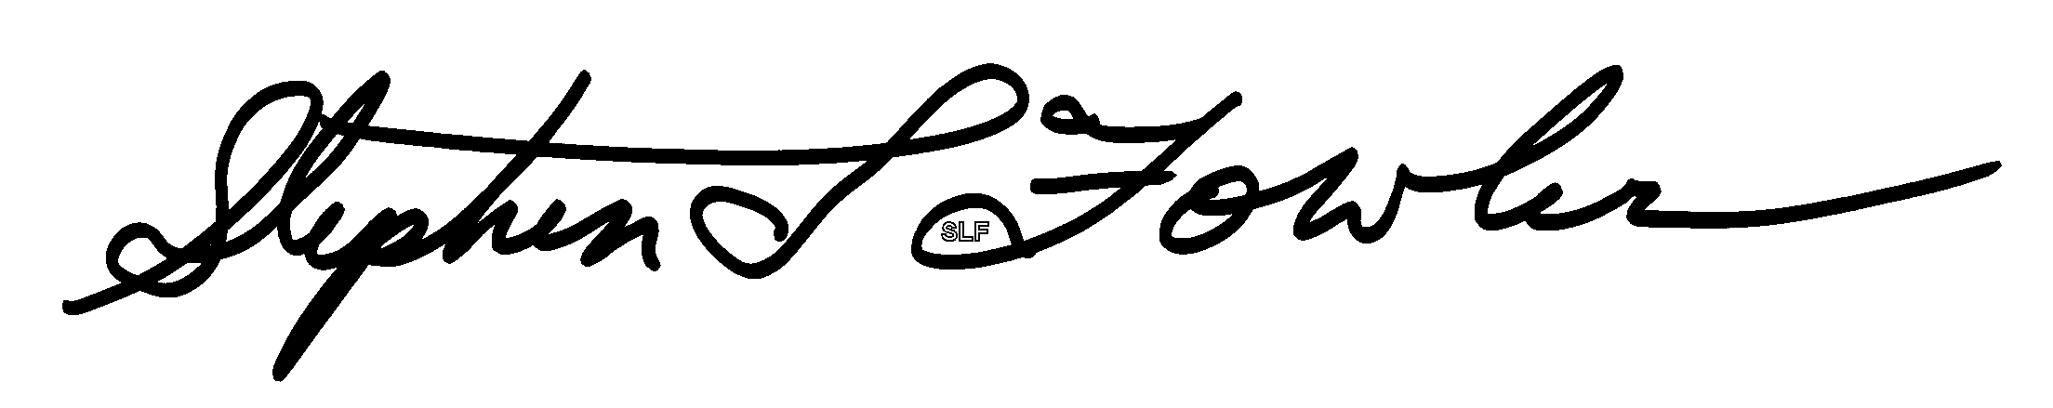
Stephen L. Fowler June 26, 2021
BSEE
North Carolina registration no. S000317 and South Carolina registration no. 00-0216 to provide radiation consultation and training
Certified ESD Control Engineer
Registered Radiation Protection Technologist (NRRPT)
Registered Radiation Safety Officer (IRRSO)

