Lipoatrophia Semicircularis : a new office disease?

900 cases reported in Belgium

Curvers Bart *, M D, occupational physician; Maes Annemarie **, Ph D, senior researcher

Short running title: Lipoatrophia Semicircularis

* KBC Bank & Insurance Group, Medical Services, Havenlaan 2, B-1080 Brussels Belgium

** VITO (Flemish Institute for Technological Research), Expertise Center of Environmental Toxicology, Boeretang 200, B- 2400 Mol, Belgium

Corresponding author:

Bart L. Curvers
KBC Bank & Insurance Group
Medical Services
Havenlaan 2
B- 1080 Brussels
Belgium

Phone: + 32 2 429 85 00
Fax: + 32 2 429 81 50
Email: bart.curvers@kbc.be

Abstract

The medical literature describes lipoatrophia semicircularis as a rare, idiopathic condition, that consists clinically of a semicircular zone of atrophy of the subcutaneous fatty tissue located mostly on the front of the thighs. The disorder is mainly afflicting office workers. Since 1995, we have diagnosed more than 900 cases in our company. Also in other companies (national and international) lipoatrophia semicircularis is diagnosed.
Several hypothesis were proposed, but no one could explain the symptoms. Although the exact cause is still unknown, we believe that electromagnetic fields play an important role in this phenomenon.

Introduction

Lipoatrophia semicircularis (LS) consists clinically of a semicircular zone of atrophy of the subcutaneous fatty tissue located mostly on the legs. Skin and underlying muscles remains intact. It is important to distinguish between the annular form of lipoatrophia and the acquired forms which develop as a consequence of injections.(1,2)

The phenomenon was reported for the first time in three patients in 1974 by Gschwandtner and Munzberger.(3,4) Since then, there have been some publications, but these relate only to 70-odd patients, whereas in our bank and insurance group we have had several hundreds cases.

Till now the aethiology of LS is unknown, the literature is mainly descriptive and as regards aetiology very hypothetical. The cause of LS remains so far speculative, most authors invariably hypothesize local mechanical pressure (microtraumata caused by either repetitive pressure against an object or by wearing tight clothing) as being on its origin.(3-12)

Clinical observations and pathology

Our story is a remarkable one. In the Spring of 1995, a total of 1100 –bank employees moved to our new office building in Brussels. The building was equipped with new data cabling, new furniture and new telephones, though most of the computer equipment was the same equipment used in our previous premises. In June 1995, a number of women were diagnosed with lipoatrophia semicircularis (LS) for the first time. Six months later, as many as 135 persons had developed this disorder and at the time of writing, nearly 8 years on, we have registrated more than 900 cases. In our local branches and other companies, too, there are increasingly more incidences of this problem. Also in other countries (e.g. France, Italy, U.K. and the Netherlands) LS is diagnosed.(16 – 20)
The disorder is mainly and mostly exclusively afflicting administrative (computer working) people.

Typically, the lipoatrophic zone is localized on the anterolateral side of the thigh, 72 cm above the floor (data gathered on patients wearing shoes) - 72 cm is also the standard height of our office furniture. The lesion can be uni- or bilateral and is between 5 and 20 cm long, about 2 cm wide and 1 to 5 mm deep. The skin remains intact.(fig. 1,2,3) By the onset of the lesions (mostly 2 or 3 months after moving into a new office), some patients mentioned a feeling of heaviness, some experienced a tingling or burning sensation, while others suffered from an increased degree of fatigue.
The lesions could disappear spontaneously after several months, but mostly improved only when people moved to another location in the building, were absent from work for a long time or were on maternity leave. However, the atrophy would come back when they returned to work in the same environment.
LS seems to be reversible. 95% of the retired employees, have no more lesions one year after leaving the company.

In anatomopathological research a perivascular lymphocytic infiltration is observed in the initial phase. In the next phase, there is a decrease in both the volume and number of adipocytes and after that a gradual replacement of the adipocytes by connective tissue. The adipocytes are reabsorbed by lysosomally active macrophages.(18 –19, 21 – 22) It is not clear whether the macrophages are the cause (by producing cytokines) or the consequence of cell destruction.

Echography, MRI or EMG research did not reveal any other abnormalities.

Personal data were recorded and from these it emerged that 84% of the disorders occurred in women, that the pathology was distributed over age groups in accordance with the employees' age pyramid and that there was no link with any other medical disorder among the employees affected.

Discussion

So far, the aethiology of lipoatrophia semicircularis is not known. The literature is mainly descriptive and very hypothetical as regards aethiology. LS must be due to a new additional factor to which people are exposed in their working environment.The lesions mostly appeared within 2 or 3 moths after moving to a new working environment.

Several authors go no further than microtraumata caused by either repetitive pressure against one object or another or by tight clothing.(9 – 12) However, this reason is too simple to explain the problem we have experienced since 1995. Firstly, if local pressure is the cause of lipoatrophia, it is amazing that we have had to wait until now to see this pathology. Secondly, local pressure can cause a local impression, but this will always disappear minutes or hours after exposure and has no relation to atrophia of the fatty tissue.

Explanations have also been sought in the area of blood circulation.

The hypothesis of an anatomical variant has been proposed in which the A.circumflexa femoris lateralis originates on the A. femoralis and not on the A. profunda femoralis.( 9) As a result, the A. circumflexa femoris lateralis is more distally located, so that pressure is exerted on this artery when a person sits down, giving rise to an ischaemic atrophy on the front of the thigh. From a purely anatomical point of view, pressure on a small part of the thigh seems to be a barely credible explanation, but most significantly this anatomical variant is found to exist in only about 3% of the population. This theory is therefore untenable when account is taken of the large size of our patient group.In one of our buildings, more than 30% of the employees was affected!

Using the same line of reasoning, it has been expounded that excessively intense muscular activity when swivelling around in an office chair could result in ischaemia in the subcutis. EMG research (see above) has revealed that a floor covered in linoleum required far less muscular strength to move about on than was the case with a carpeted floor. With carpeting, up to 80% of the maximum muscular strength of the M. Quadriceps and 50% of the strength of the hamstrings is used; with linoleum these values are one-third lower. Therefore, it was decided to conduct an experiment by replacing wall-to-wall carpeting with linoleum. This operation did not yield any clinical results.

Because the sitting posture and particular characteristics of the chair could have an influence on the compression pressure on the distal side of the back of the thigh and therefore might cause a vascular disturbance, an ergonomic investigation focusing on the sitting position was carried out by the University of Louvain.(13) The tables and chairs complied with ergonomic guidelines, but on the whole the staff were seen to sit fairly high and not to make use of the arm- and back rests, even though the chair was equipped with these features. In an analysis of body posture (the aim of which was to avoid musculoskeletal complaints), it was established that more than half of the employees did not make use of the lumbar backrest, bent the head far forward when working and assumed a fairly static body posture; just under half of the workers did not use any rest for the forearms.
Further investigations were carried out on 21 workers (11 with and 10 without LS).(13) A video analysis was made of postures and movements and an electromyographic measurement was made in order to study the muscular tension on the front and the back of the thigh. In addition, a technological study of the pressure conditions below the thighs was carried out by using a 42x42 cm pressure pad which contained a grid of 512 capacitive sensors. From the video recordings and the electromyographic observations it clearly emerged that persons with Ls moved less, sat further forward on the chair and had a tendency to sit too high. The pressure measurements demonstrated that pressure increased by more than 30% at the distal extremity of the thigh when the seat of the chair was 5 cm too high in relation to the ideal height and that a footrest was a very good way of addressing this problem. When the seat is tilted forward (i.e. an open angle), pressure is at its lowest. However, the research demonstrated that there was no difference between those who suffered from lipoatrophia and those who did not.
It was decided to remedy this by offering those who were interested an individual assessment of their own sitting posture. 176 employees were surveyed, which led to an improvement of the posture at work and a decrease in musculoskeletal complaints in a number of staff members, but did not bring about any improvement of the phenomenon of LS.

Recently, a new study on sitting was carried out. The hypothesis was that a bad sitting posture causes shearing forces on the back of the thigh, which can cause an ischeamic zone on the front side of the leg, thus leading to lipoatrophia. This study was carried out with the University of Rotterdam (Nl), but failed to come up with a solution to our problem.(14)

In our situation, the following question arises: what has changed in the work situation as a result of the move to the new premises? The more obvious new factors were the building, furniture and wiring. A large-scale technical research project was carried out.

A specialized firm of consultants conducted an investigation into indoor air quality: The degree of dust creation was considered to be good or very good everywhere; the CO2 content was not above 600 ppm anywhere; the microbiological quality was good, including the concentrations of endotoxins. Thermal comfort was good, but the relative humidity was too low (around 40%). The ozone content in the surrounding air never reached 0.01 ppm and the radon content above ground remained under 20 Bq/m³ and below ground 40-70 Bq/m³, where the limit value in dwellings is 150 Bq/m³. Radioactivity in the building did not exceed the measurements for the surrounding environment.

A pilot study for electric and magnetic fields was carried out, first at the frequency of 50 Hz.(15) The magnetic field fluctuated for the most part around 0.2 mG, with an occasional value of 2 mG, the recommended maximum. The electric field ranged up to 150 V/m for a non-earthed cable conduit full of cables; when the cable conduit was earthed, the value never exceeded the standard value of 16 V/m. The electric field strengths were always appreciably higher when someone was seated at the workstation than when not. From the findings of this research, a proposal was made to earth all workstations. The clinical results of this earthing have been conspicuous by their absence.

A subsequent study included the VLF and LF fields, as well as the ULF or microwave frequencies at 915 and 2450 MHz. No abnormally high magnetic field strengths were observed anywhere, compared with the generally accepted underground load or limit values.

Another hypothesis related to electrostatical discharge (ESD) to the thighs via the desk top.(26 - 27) In this hypothesis, the conductivity of the desk top plays a mayor role; the surface resistance varies from 20x10 to 1x10.ohms according to the material and finish of the desk tops examined. Preferably, they should be as low as possible.
Local electrostatic discharges on that region of the legs, where the human body is coupled with the edge of the table, can in a biological plausible way explain what is happening in the lipoatrophic tissue. Activated macrophages produce cytokines; e.g. TNFα that is able to damage adipocytes and modify the structure of adipose tissue.(22 – 25)( fig.4) Extensive experiments have been carried out with ALU plate and ALU post in which data and other cables are stored, but all experiments failed to produce any noteworthy results.

A new pilot project in the electromagnetic domain was recently completed. The goal was to limit the amount of litter on the cable network. To this end, the entire cabling (for the PC network, telephones and electricity) on one floor was replaced with ferrite cables. This has drastically reduced the litter and the electromagnetic fields it creates. There has been a clear improvement in the condition of those employees affected by LS. In some cases there has been a complete recovery. To-date, this is the only trial to have given a positive result for all those affected. This reinforces our belief that the cause of LS should be sought in the area of electromagnetics. (27)

Conclusion

This report sets out the history of a remarkable problem, a problem we are still trying to find a solution to. Although this disease is catalogued as a very rare one, it is now occurring very frequently at least in certain workplaces.
We may concluded that the frequent occurrence of lipoatrophia semicircularis is directly related to modern new office buildings and new working environments. Probably the cause as well as the solution is a multifactorial one. Although the cause is still unknown, we believe that electromagnetic fields play an important role in this phenomenon.

REFERENCES

- Atlan-Gepner C, Bongrand P, Farnarier C, Xerri L, Choux R, Gauthier J.F,Brue T,Vague P, Grob JJ, Vialettes B. Insulin-induced lipoatrophy in type I diabetes.Diabetes Care.1996; 9: 1283-1285.
- Imamura S, Taniguchi S. Lipoatrophic lesions preceded by pain and erythema a new clinical entity? Eur. J. Dermatol. 2000; 10: 540-541

- Gschwandtner WR, Münzberger H. Lipoatrophia semicircularis. Ein Beitrag zu bandförmig-circulären Atrophien des subcutanen Fettgewebes im Extremitätenbereich. Der Hautartz 1974; 25: 222-227

- Gschwandtner WR, Münzberger H. Lipoatrophia semicircularis. Wiener klein. Wochenschr. 1975; 87: 164-168.

- Karavitsas C, Miller JA, Kirby JD. Semicircular lipoatrophy. Brit. J. Dermatolol. 1981; 105: 591-593.

- Ayale F, Lembo G, Ruggiero F, Balato N; Lipoatrophia semicircularis,report of a case. Dermatologica 1985; 170:101-103.

- De Rie MA. Indrukken op de bovenbenen ; Lipoatrophia semicircularis. Ned. Tijdschr. Geneesk. 1998; 142: 796-797.

- Nagore E, Sanchez-Motilla JM, Rodriguez-Serna M, Vilata JJ, Aliaga A. Lipoatrophia semicircularis- a traumatic panniculitis : report of seven cases and review of the literature. J. Am. Acad. Dermatol. 1998; 39: 879-881.

- Bloch PH, Runne U. Lipoatrophia semicircularis bein Mann. Zusammentreffen von Arterienvarietaät und Microtraumata als mögliche Krankheitsursache. Der Hautartz 1978; 29: 270-277.

- Mascaro JM, Ferrando J. The perils of wearing jeans: Lipoatrophia semicircularis. Int. J. Dermatol. 1983; 22: 333.

- Hodak E, David M, Sandbank M. Semicircular lipoatrophy – a pressure-induced lipoatrophy? Clin. Exp. Dermatol. 1990; 15: 464-465.

- De Groot AC. Is lipoatrophia semicircularis induced by pressure? Brit. J. Dermatol. 1994; 131: 887-890.

- Hermans V, Hautekiet M, Haex B, Spaepen AJ, Van der Perre G. Lipoatrophia semicircularis and the relation with office work. Appl. Ergonomics 1999; 30: 319-324.

- Verbelen C. Lipoatrophia semicircularis in relatie met zitten vanuit het biomechanisch model. BMA Ergonomics 2002.

- Decat G. Evaluatie van de elektromagnetische velden in de werkomgeving van het hoofd- en enkele bijkantoren van de Kredietbank. Vito report 1997; TAP.RV97035.

- Senecal S, Victor V, Choudat D, Hornez-Davin S, Conso F. Semicircular lipoatrophy: 18 cases in the same company. Contact Dermatitis 2000; 42: 101-120.

- Gruber PC, Fuller LC. Lipoatrophy semicircularis induced by trauma. Clin. Exper. Dermatol. 2001; 26: 269-271.

- Schnitzler L, Verret J.-L, Titon J.-P. La lipoatrophie semi-circulaire des cuisses. Ann. Dermatol. Venereol. 1980; 107: 421-426.

- Pibouin M, Laudren A, Mignard MH, Chevrant-Breton J. Lipoatrophie semi-circulaire des cuisses. Sem. Hop. Paris 1986 ; 62 : 3760-3762.

- Filona G, Bugatti L, Nicolini M, Ciattaglia G; Lipoatrofia semicircolare: due casi. Unita Operativa di Dermatologia Ospedale “ A. Murri” ASL

- Dahl PR, Zalla MJ, Winkelmann RK. Localized involutional lipoatrophy: a clinicopathologic study of 16 patients. J. Am. Acad. Dermatol. 1996; 35: 523-528.

- Zalla MJ, Winkelmann RK, Gluck OS. Involutional lipoatrophy: macrophage-related involution of fat lobules. Dermatology 1995; 191: 149-153.

- Petruschke Th, Hauner H. Tumor necrosis factor-α prevents the differentiation of human adipocyte precursor cells and causes delipidation of newly developed fat cells. J. Clin. Endocrinol. Metabolism 1993 ; 76 : 742-747.

- Prins JB, Niesler CU, Winterford CM, Bright NA, Siddle K, O’Rahilly S, Walker NI, Cameron DP. Tumor necrosis factor-α induces apoptosis of human adipose cells. Diabetes 1997; 46: 1939-1944.

- Gamaley I, Augsten K, Berg H. Electrostimulation of macrophage NADPH oxidase by modulated high-frequency electromagnetic fields. Bioelectrochem. Bioenerget. 1995; 38: 415-418.

- Maes A,.Verschaeve L. Contractverslag L 3211 2000/TOX/R/002 VITO Boeretang 200 B-2400 Mol

- Maes A, Curvers B, Verschaeve L. Lipoatrophia semicircularis: the electromagnetic hypothesis. Electromagnetic Biology and Medicine 2003; 22 (2), in press.

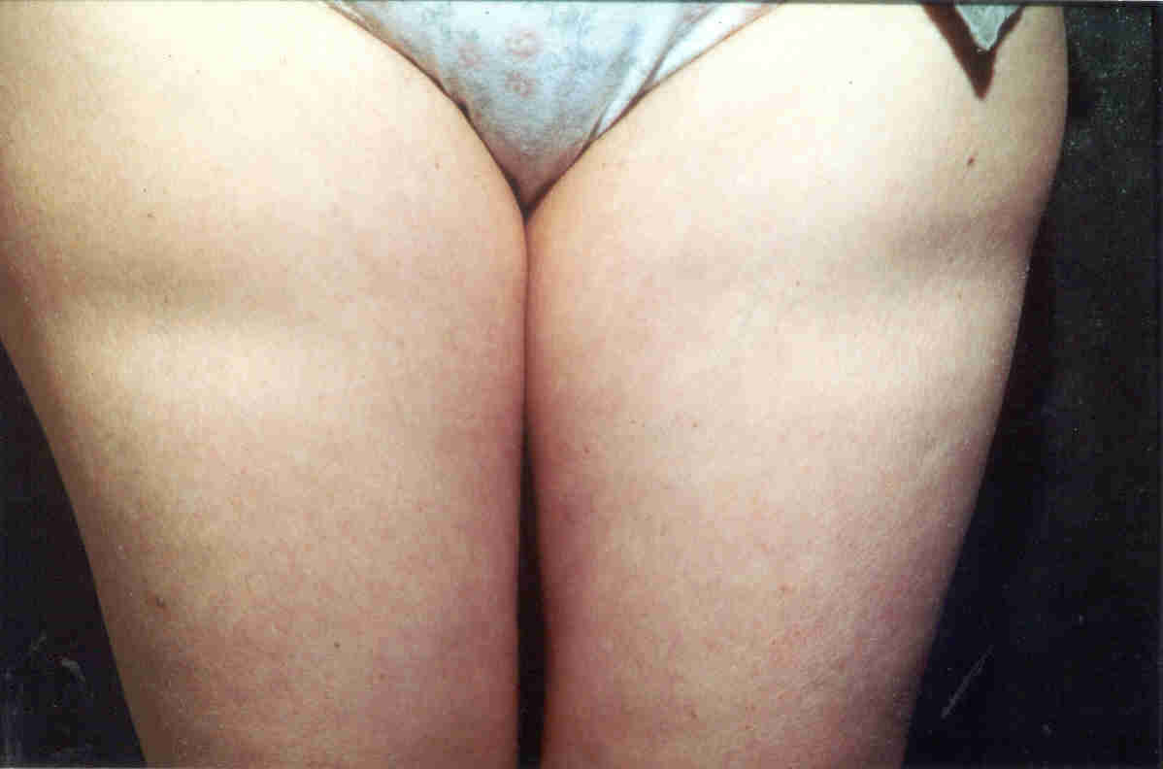

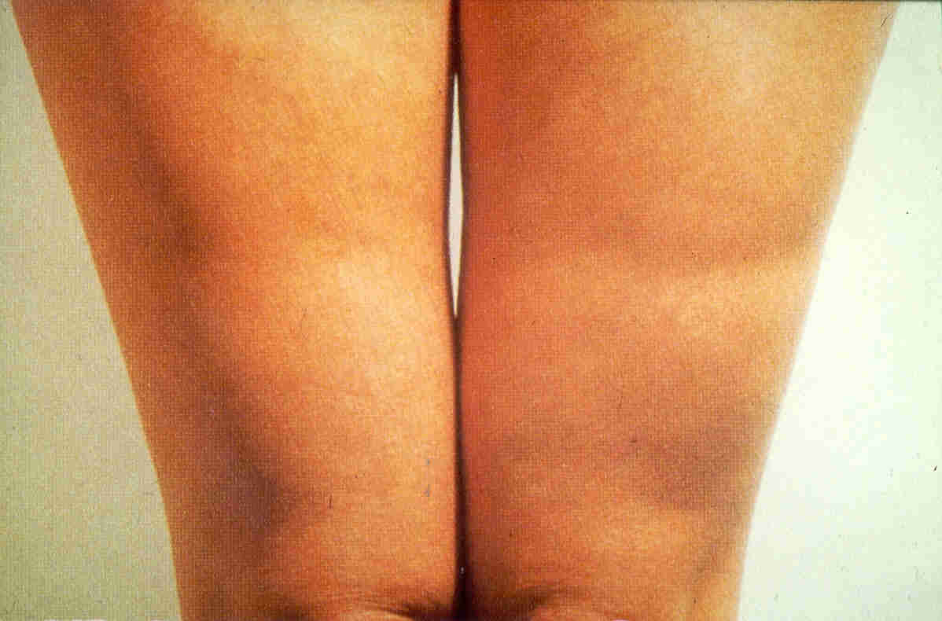

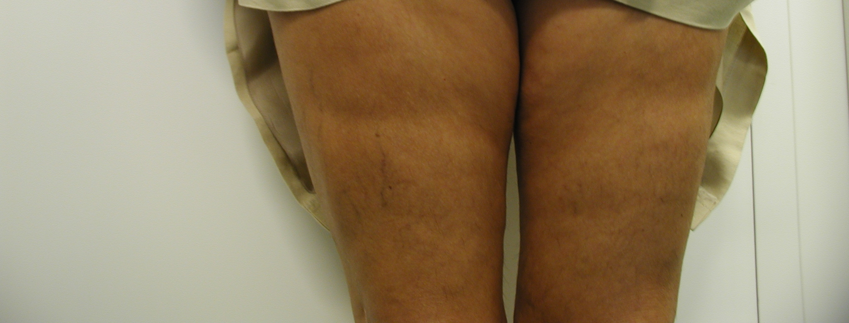

Fig. 1,2 and 3 : Semicircular zones of lipoatrophia on the front of

the thighs



Fig. 4 : Biological hypothesis of the atrophia of the subcutaneous fatty tissue.

